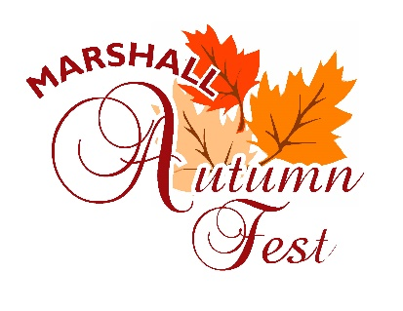

P.O. Box 222 Marshall, IL 62441 | (217) 826-2034
September 17,18,19
**Decorate with anything fall related**
Greetings:

The Marshall Autumn Fest Committee would be pleased to have the participation of your group or organization, in our annual Autumn Fest Parade to be held on Saturday, September 18, 2021. The parade will begin at 11:00 a.m. with registration and line up scheduled from 8:15 a.m. to 10:30 a.m. prior to parade time. All units must report to the high school parking lot, located on 5th street, the registration booth will be located in that area. Those having a float and want to be judged must be in place by 10:00 a.m.

Activities are planned all weekend beginning on Friday, September 17, 2021 at 6:00 p.m. There will be plenty of free entertainment, great food, booths, and activities for all ages. Plan now to be a part of this great Autumn Fest. In an effort to help us be self supporting, we are asking for a donation of your choice for each entry.

Again, this year we ask that if you intend to distribute candy—please make arrangements to have “walkers” to hand it out. For the safety of our children, PLEASE do not throw candy from parade vehicles. We look forward to your participation in the Autumn Fest Parade.

Buffy Wernz, Parade Chairman
Please return bottom portion of this form to:
Parade Chairman-Marshall Autumn Fest- P.O. Box 222, Marshall, IL 62441.

Name: __________________________________________

Address: ________________________________________

Contact Phone Number: ____________________________

Name of Organization Sponsoring Unit: _______________

Unit Specifications: ___________________

For Office Use Only:

Donation Given: ________ Parade Number_______________________

